SmartSwitch Model SMS-8
Functional Description of Operation
for
Commonwealth Building

This document describes the operation of a SmartSwitch Technologies Model SMS-8 applied to a Building Systems Monitoring and Alarm System for Commonwealth Building. The system programming and integration is by Text Control Systems, Export, PA.

The SMS-8 allows monitoring of up to eight (8) contact closure inputs and control of up to four (4) devices via logic level outputs rated at 400ma. Control of devices requiring higher power must use interposing relays sized for the application. All programming is accomplished using text message commands via a cell phone. All alerts for off-normal conditions and commands to interrogate input/output status or to control devices are via text messages.

It is very important that all users read and understand general operation and the text commands and responses which the SMS-8 accepts and sends. These are described in the SmartSwitch SMS-8 manual available for download at http://www.smartswitch.co.nz/downloads.asp Click on “Installation Manual - SMS-8”

For the Building Systems Monitoring and Alarm System for the
Commonwealth Bldg, the following I/O assignments are made:

- Inputs:
  - Eight (8) contact inputs with normally closed contacts. These inputs are from various building sensors as follows:
    - Tower Water Temp High
    - Tower Water Pressure Hi/Low
    - Condenser Water Temp High
    - Comp 1 Gas Hi/Lo
    - Comp 2 Gas Hi/Lo
    - Comp 3 Gas Hi/Lo
    - Boiler Room Motion Detected
    - Elevator Room Motion Detected
  - Inputs remaining = 0

- Outputs:
  - None Implemented
  - Outputs remaining = 4
The assignment of the inputs and outputs is as shown in the following table:

Input | Default  Name | Name (up to max 20 characters) | Latched  Yes No | Linked  to | Active  Open  or  Closed | Time Delay  (Upon  activation or deactivation)
1 | Input1 | Tower-water-temp-h | No | N/A | Open | 5 Min (A)
2 | Input2 | Tower-water-press-h | No | N/A | Open | 5 Min (A)
3 | Input3 | Cond-water-temp-h | No | N/A | Open | 5 Min (A)
4 | Input4 | Comp1-press-h-l | No | N/A | Open | 5 Min (A)
5 | Input5 | Comp2-press-h-l | No | N/A | Open | 5 Min (A)
6 | Input6 | Comp3-press-h-l | No | N/A | Open | 5 Min (A)
7 | Input7 | Boiler-room-motion | No | N/A | Open | 5 Min (D)
8 | Input8 | Elevator-room-motion | No | N/A | Open | 5 Min (D)
Output
1 | Output1 | Spare | N/A | N/A | N/A | N/A
2 | Output2 | Spare | N/A | N/A | N/A | N/A
3 | Output3 | Spare | N/A | N/A | N/A | N/A
4 | Output4 | Spare | N/A | N/A | N/A | N/A

Note that names are limited to 20 characters and no spaces. Important: Note the dash (–) between all words in the names. This dash must be included to identify input and output names when the user sends text commands.

Optional settings for the inputs that have been implemented in this system are as follows:

- Inputs #1 through #6: Inputs have a time delay of 5 minutes upon activation (ie: contact opening). This time delay accounts for the situation where an input sensor may temporarily open and then return to normal. Each time the contact closure opening is sensed, the internal timer restarts the five minute countdown. If the input remains open for more than five (5) minutes, the alert will be triggered and a text message sent. (The time delay is adjustable by program command)
- Inputs 7 & 8: Motion Detector Inputs will be alerted (text sent) immediately upon activation, but have a time delay of 5 minutes upon deactivation (ie: contact closing). Motion detector inputs are alerted immediately with a text message to all users. However, the time delay accounts for the situation where a motion detector may temporarily close because the intruder has stopped moving (or is temporarily out of range) at which time the motion detector’s contact would reclose. Because each change of state results in a text message, the time delay eliminates multiple messages being generated. Each time the contact closure opening is sensed, the internal timer restarts the five minute countdown. At the expiration of the 5 minute delay, if the contact has closed, a text will be sent saying the contact has “turned off”.
Operating Instructions

The SMS-8 will send the following text messages to all identified “Users” based on a change in state of inputs. User commands for various situations are shown along with the SMS-8 text response.

Condition | Text Received | Text Commands | Purpose
Example: Tower water temperature sensor opens indicating high temperature | Tower-water-temp-h has been turned on
Tower water temperature sensor closes indicating temperature has returned to normal | Tower-water-temp-h has been turned off
To interrogate SMS-8 on the status of all inputs |  | User: Input status  SMS-8 response: Current State of each input – “Off” or “On”
Query voltage of SMS supply |  | User: Voltage status  SMS-8 response: Battery is currently XX.X volts
To interrogate SMS-8 on cell signal strength |  | User: Sig  SMS-8 response: Current percent cell signal (ex: 67%)
To temporarily discontinue text alerts when personnel present in boiler room or elevator room |  | User: Alerts off  SMS-8 response: Alerts have been Disabled | To temporarily discontinue text alerts**
To restore text alerts when personnel leave monitored rooms |  | User: Alerts on  SMS-8 response: Alerts have been Enabled | To restore text alerts
** With alerts turned off the device will NOT text each time an input changes state, but the inputs are still active so you can send an “Input status” query at any time.

A full description of the Commands and other functions of the SMS-8 can be found in the Installation Manual.

Notes:

- The phone number of the SIM in SMS-8 is 412-515-xxxx. Add this to your cell phone’s contact list.
- The following phone numbers have been added to the “user list” to receive SMS messages:
  - 847-579-xxxx
  - 773-255-xxxx
  - 312-504-xxxx
  - 847-489-xxxx
- Input and Output names can be up to 20 characters in length and names may be changed within these parameters.
- A time delay can be applied to any input to prevent nuisance text alarms.
Time delay can be between 1 and 99 seconds or 1 to 99 minutes
- Direct connection of any input to any output (not implemented in this system): Because the SMS-8 internal logic allows direct connection (not depending on a text command to activate) of any input to any output, various functions can be configured to provide local (on-board) alerts.
- Battery Supply Alarm: The SMS-8 monitors its own supply power. If battery power drops below 11.5 volts (12v system) or 22.5 volts (24v system), a text message alert will be generated. (Monitoring the battery does not use any inputs from the available 8.)
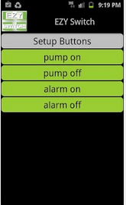
- SmartSwitch APP: Text commands are facilitated by using the SmartSwitch APP for either iPhones or Android devices. The APP provides up to 10 customized commands sent with the tap of a button and is available at http://www.ezyswitch.co.nz/resources/
- See next page for the wiring diagram for this system.
- IMPORTANT: Your provider for cell service is AT&T Wireless. The plan that has been established for your is a “Go Phone–Pay–as-you-go” plan. You will NOT add any money to the calling plan portion as your system will not make phone calls. Rather, you will only activate a “Feature” for 200 text messages per month. The monthly cost of the “feature” is $4.99 + tax. (See page 7 for a copy of the plan and status of the remaining text messages and expiration date.) Note that the account balance should always be $0.00. You are only concerned with the Messaging Plan balance and the expiration date since you must renew monthly or set up an automatic renewal.) Log into your account at https://www.paygonline.com/websc/logoff.html using the SIM phone number 412-515-xxxx and your password which is xxxx. You should change the profile to your own personal data.

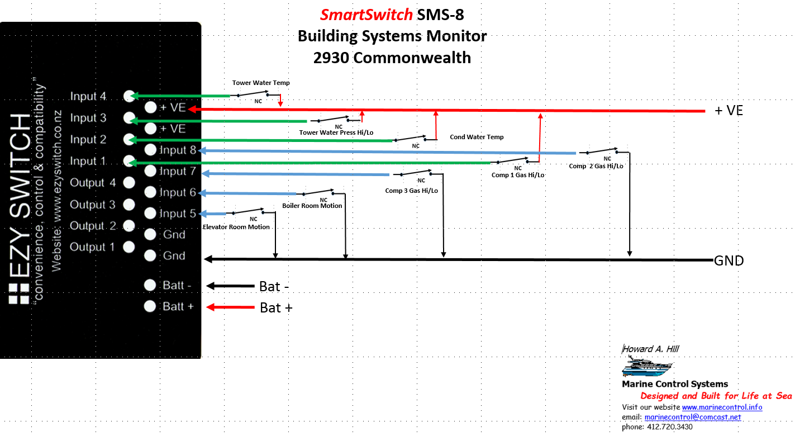
Bilge 2 Not Implemented
Supplemental Warranty and Disclaimer
For Text Alert Systems

Your SmartSwitch, model SMS-8, has been configured based on specifications submitted. The system operation has been tested and verified by Marine Control Systems to conform to the operation described in the foregoing Functional Description of Operation and SmartSwitch SMS-8 Installation manual.

Text monitoring systems depend on a variety of installation and operational factors to provide accurate and timely alerts of building systems status. These include, but are not limited to, proper physical and electrical installation and the availability of sufficient signal strength from the cell provider for text messages to be sent and received. Also, the contract with the cell provider must be kept current to maintain the texting service. In addition, since the SMS-8 is powered by battery or 12v DC adaptor, sufficient power is required at a constant 11.5v to 30v DC for its operation. The minimum amperage available at SMS-8 input terminals must be at least 1 amp. Peripheral devices such as building systems sensors must be well maintained and in good working order.

Therefore, the owner should NEVER RELY ON A TEXT MESSAGING ALERT SYSTEM AS THE SOLE METHOD OF PROVIDING SECURITY AND BUILDING SYSTEMS’ STATUS. THE TEXT ALERT SYSTEM SHOULD BE CONSIDERED SECONDARY AND SUPPLEMENTAL TO OTHER BUILDING MONITORING SYSTEMS AND NEVER AS THE PRIMARY MEANS OF MONITORING BUILDING SYSTEMS’ STATUS.

Whereas the above described and other factors can affect the accuracy and timeliness of text alerts provided by a text monitoring system, and those factors are beyond the scope and control of either SmartSwitch Technologies or Marine Control Systems, therefore, IN NO EVENT WILL SMARTSWITCH TECHNOLOGIES OR MARINE CONTROL SYSTEMS ACCEPT ANY LIABILITY FOR DIRECT, INDIRECT, OR CONSEQUENTIAL DAMAGES OR LOSSES WHATSOEVER OR HOWSOEVER ARISING FROM THE USE OF THIS PRODUCT.

The statement of warranty and general limits of liability are set forth in SmartSwitch Warranty and the Marine Control Systems Selling Policy SST-100, dated July 15, 2014 which have been provided as separate documents. THIS DISCLAIMER FOR TEXT ALERT SYSTEMS IS IN ADDITION TO AND SUPPLIMENTAL TO THOSE DOCUMENTS.

